### Preproduction Stage B Deliverables: Garden of Math and Evil

#### USER TESTING: Used to gauge interest and usability related to art in addition to mechanics.

* User testing has been positive as a means to introduce complicated math tools such as probability and fractional mathematics

#### ART DELIVERABLES (LISTED IN ORDER OF COMPLETION)

* **Art Theme Reference Board** (Art) – a quick compilation of found art providing inspiration and ideas for possible visual themes prior to creating mock-ups.
* **3+ Theme Mock-Ups** – quick sketches of how the game might look in different themes.
* **Screen Explorations** – continued sketching or lo-res exploration of:
  + Game screens – showing how selected theme will look on each screen/pop-up.
  + Visual presentation of game mechanics – planning their visualization/animation.
  + Visual presentation of interaction feedback – planning visualization/animation.

QUESTIONS DELIVERABLE MUST ANSWER:

* What theme will we apply to this set of game mechanics?.
  + Carnival (Duck Pond Game)
    - Has the exciting, familiar environment of a carnival game
    - Distinct from other Lumosity themes/games
    - Less complicated than the depth implied by the bear-shelf game
    - Sarahs Notes:
      * Make sure the carnival theme is expressed clearly
      * Make sure stimuli isn't too juvenile
  + ~~Butterfly~~
    - ~~Seems more gentle, slower~~
    - ~~Users like nature theme (some do not like bugs)~~
    - ~~No solid narrative or role for the user~~
* What does that theme look like at the major touch points of a game (e.g.: Splash screen, level select screen, low level, high level)?

~~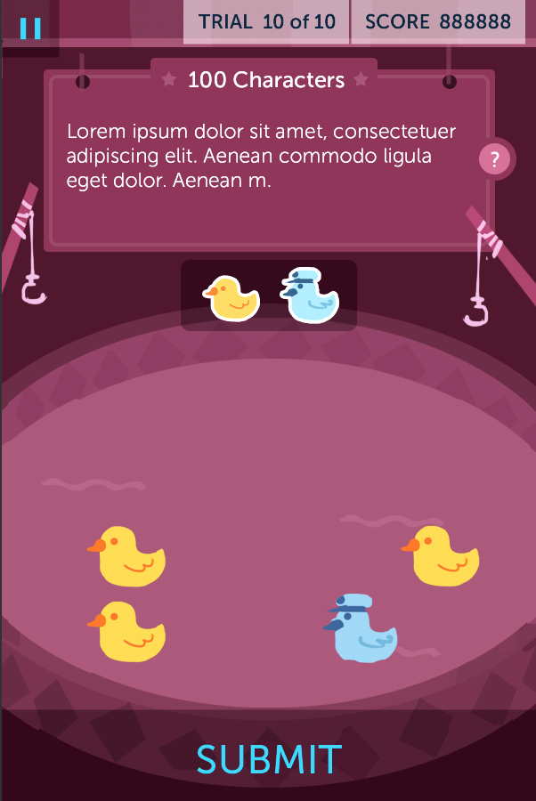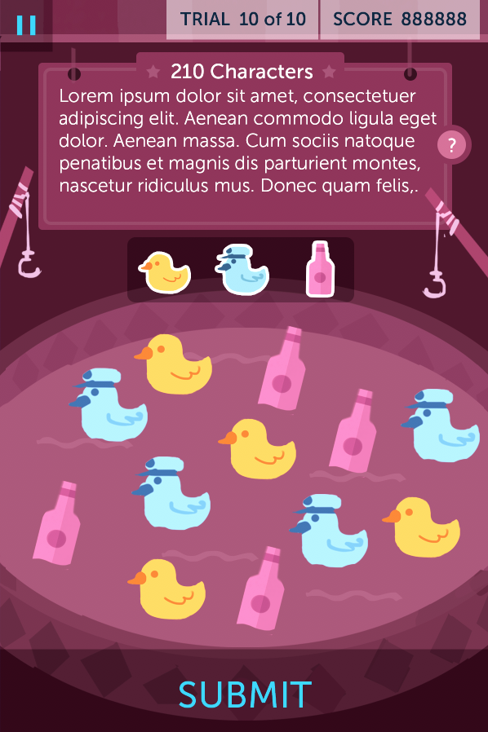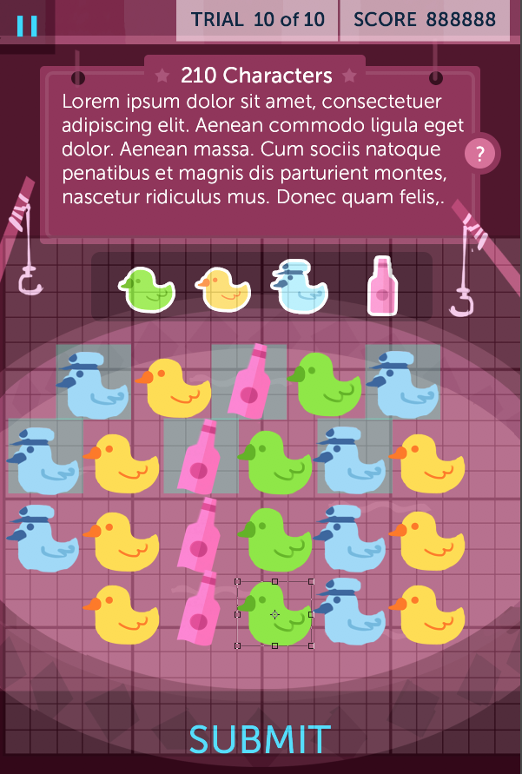~~

* Are there any special case animations or design elements that need to be proven out for this theme concept to work (e.g.: The masking of animals in River Ranger or the 3D trains in ToT)?
  + N/A
* How will we teach the game’s mechanics to players? What actions will we teach to the player, and in what order?
  + 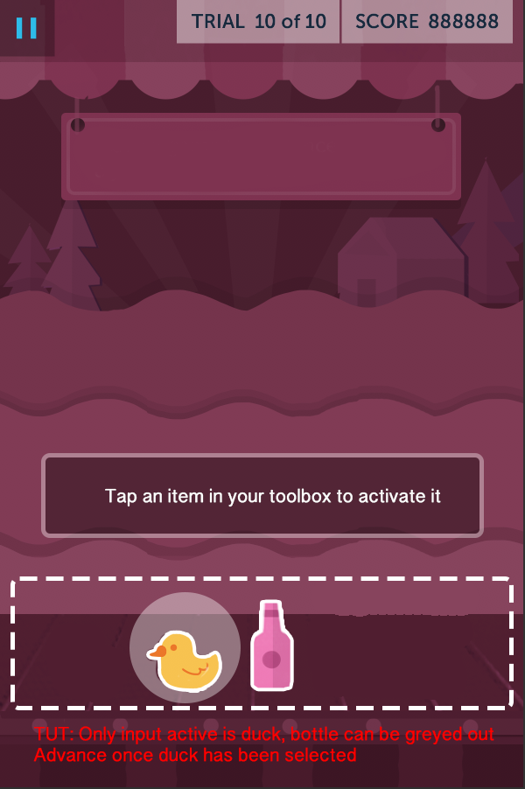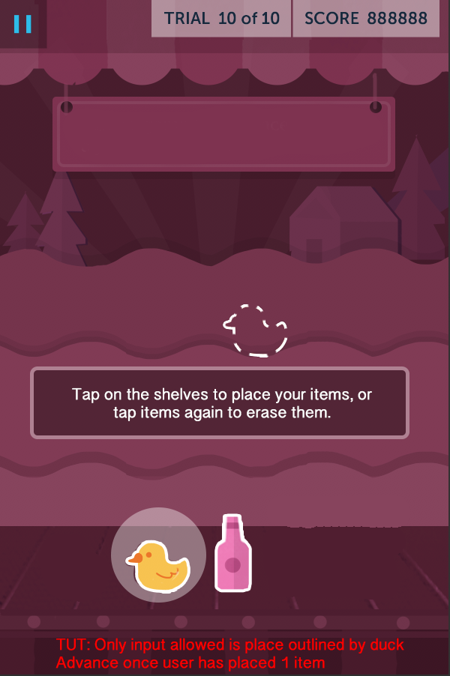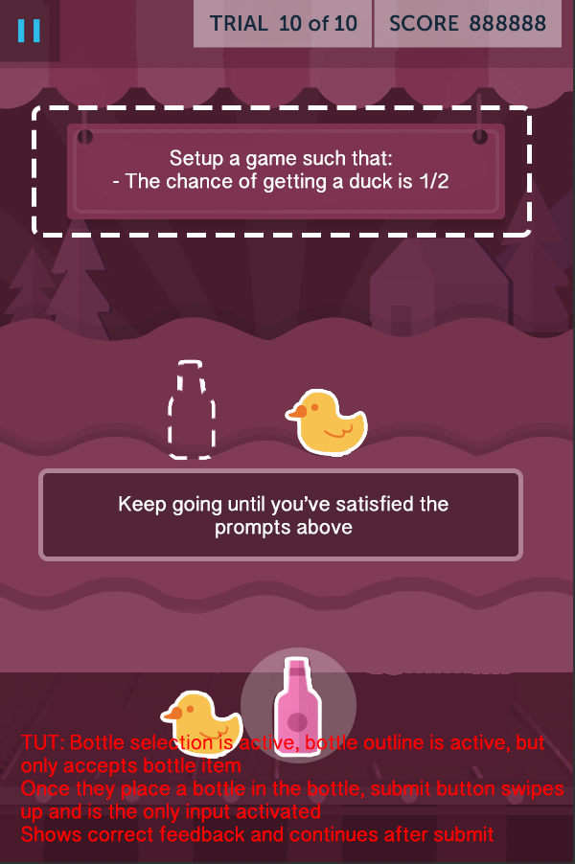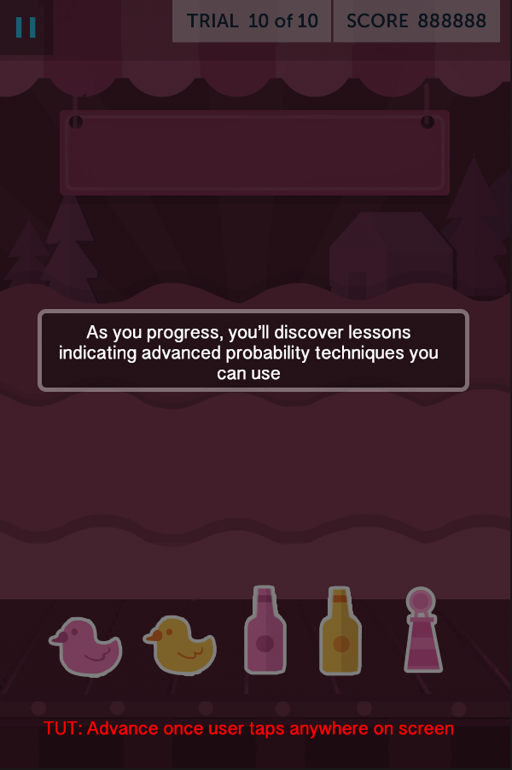
* How will we ensure the game provides clear, timely, and positively reinforcing feedback to your interactions w/ the game’s training mechanics?

CRITERIA TO ADVANCE: To progress the team and stakeholders need a shared vision for what the finished game will be. Consensus is needed on how the game’s difficulty will adapt, in what ways players’ cognitive ability will be measured and performance scored, and how we’ll ensure the game will continue to offer effective, engaging training even after hundreds of play sessions. Essentially the full game design should be complete, planned, well-scoped and ready for scheduled production, without large outstanding design or production questions remaining.

### SIGNOFF: Science, Game Systems, Engineering, PM, UX, Art, QA